A Project Report

On
PLACEMENT MANAGEMENT SYSTEM

carried out as part of the lab IT2232 Web Technologies Submitted

by

Ishika Singh
229302167

in partial fulfilment for the award of the degree of

Bachelor of Technology

in

Information Technology



School of Information, Security and Data Science
Department of Information Technology

MANIPAL UNIVERSITY JAIPUR
RAJASTHAN, INDIA

April 2023

CERTIFICATE

Date

This is to certify that the project titled PLACEMENT MANAGEMNT SYSTEM is a record of the bonafide work done by ISHIKA SINGH (229302167) submitted in partial fulfilment of the requirements for the award of the Degree of Bachelor of Technology (B.Tech) in (Discipline) of Manipal University Jaipur, during the academic year 2023-24.

Dept Guide Name: Ms Rashmi Bartwal

Project Guide, Dept of information technology
Manipal University Jaipur

HOD Name: Dr Pankaj Vyas

HOD, Dept of information technology

Manipal University Jaipur

ABSTRACT

In the contemporary educational landscape, the efficient management of student placements is paramount for both academic institutions and students alike. With the burgeoning demand for skilled professionals in diverse industries, the placement process acts as a pivotal bridge between academia and the professional world. Thus, the development of a streamlined Placement Management System (PMS) emerges as a critical need in the present scenario.
This project endeavours to address this need by harnessing modern web technologies such as Express.js, Workbench, HTML, and CSS to create a robust and user-friendly PMS. The primary objective of the project is to provide a comprehensive platform that centralizes student information, facilitating seamless interaction between students, academic advisors, and prospective employers.

The methodology adopted involves thorough research into the existing challenges of placement management, followed by the conceptualization and development of a feature-rich web application. Leveraging the power of Express.js for backend development and HTML/CSS for frontend design, the system offers intuitive navigation and a visually appealing interface.

The implementation phase involves rigorous testing and iterative refinement to ensure functionality, security, and scalability. Noteworthy results include the successful integration of student profiles, academic records, and placement history into a unified dashboard accessible to authorized users.

The significance of this project lies in its potential to streamline and enhance the placement process, ultimately benefiting students by increasing their visibility to recruiters and empowering academic institutions with efficient management tools. Moreover, the utilization of modern web technologies underscores the project's relevance in the digital age, where seamless connectivity and accessibility are paramount.
LIST OF TABLES

Table No | Table Title | Page No

LIST OF FIGURES

Figure No | Figure Title | Page No

 | Contents
 | Page No
Abstract | i
List Of Figures
List Of Tables

Chapter 1 INTRODUCTION

1.1 Introduction to work done/ Motivation (Overview, Applications & Advantages) 1

1.2 Project Statement / Objectives of the Project

1.3 Organization of Report

Chapter 2 BACKGROUND OVERVIEW

2.1 Conceptual Overview (Concepts/ Theory used)

2.2 Technologies Involved

…

Chapter 3 METHODOLOGY

3.1 Detailed methodology that will be adopted

3.2 Circuit Layouts / block diagrams
…

Chapter 4 IMPLEMENTATION AND RESULTS

4.1 Modules

4.2 Prototype

…

FUTURE WORK AND CONCLUSION
Chapter 5

5.1 Progress Chart/Time Line Chart

5.2 Future Work and Conclusion

REFERENCES

ANNEXURES (OPTIONAL)

CHAPTER 1 : INTRODUCTION

The Placement Management System is a web-based application designed to facilitate the management of student placements. It features a user-friendly interface for adding and viewing student data, and filtering options based on various criteria. The system provides functionalities for tracking the status of each student’s placement process, ensuring data security through user authentication, and sending automated email notifications to inform students of their placement status.

The primary objective of this project is to develop a Placement Management System that simplifies and streamlines the student placement process in educational institutions. By automating tasks that were traditionally performed manually, such as updating spreadsheets, the system aims to enhance the efficiency and accuracy of placement management.

CHAPTER 2: BACKGROUND OVERVIEW

The Placement Management System (PMS) developed encompasses both frontend and backend components to facilitate efficient management of student placements. The frontend, built using HTML, CSS, and JavaScript, provides a user-friendly interface for interacting with the system. It consists of an index.html file, which serves as the main entry point, and a form.html file for adding new student data. The backend, powered by Express.js, handles data retrieval, insertion, and deletion operations using RESTful APIs. The data is stored in a MySQL database, comprising tables for student information and placement records.

Technologies Used:

- Frontend Development:

  - HTML: Provides the structure and layout of the web pages.
  - CSS: Styles the HTML elements for visual presentation and user interface design.
  - JavaScript: Enables dynamic behavior and interaction within the web pages.
  - Axios: A JavaScript library for making asynchronous HTTP requests from the frontend to the backend.

- Backend Development:

  - Express.js: A Node.js framework for building server-side applications, handling routes, and managing middleware.
  - Node.js: A JavaScript runtime environment that executes JavaScript code outside of a web browser.
  - MySQL: A relational database management system for storing and managing structured data.
  - MySQL Workbench: A visual tool for designing, developing, and administering MySQL databases.

Functionality Overview:

- Frontend:

  - Index.html: Displays a table populated with student data fetched from the backend.
  - Form.html: Provides a form for adding new student information to the database.
- Backend:

  - Express.js App: Hosted on port 3000, the Express.js application defines routes to handle incoming requests.
  - GET /students: Retrieves an array of all students from the database and sends it to the frontend.
  - POST /students: Inserts a new row with student data into the database, received from the form submission on the frontend.
  - DELETE /students/:student_id: Deletes a row from the database corresponding to the provided student ID.

Data Management:

- MySQL Database:

  - Students Table: Stores information such as student ID, name, academic records, etc.
  - Placements Table: Contains data related to student placements, including placement ID, company name, date of placement, etc.

Technology Used
    - Hardware Requirement
- None specified, as it is a web-based application primarily requiring a server. Currently functioning on an AWS cloud hosted linux server
    - Software Requirement
- Front-End: HTML,CSS,JAVASCRIPT
- Back-End: express.js
- Database Management: MySQL or suitable RDBMS
- Web Server: Apache or Nginx
- Development Tools: Visual Studio Code, Git for version control
- Security Tools: SSL certificates, Firewalls
- Testing Frameworks (React Testing Library)

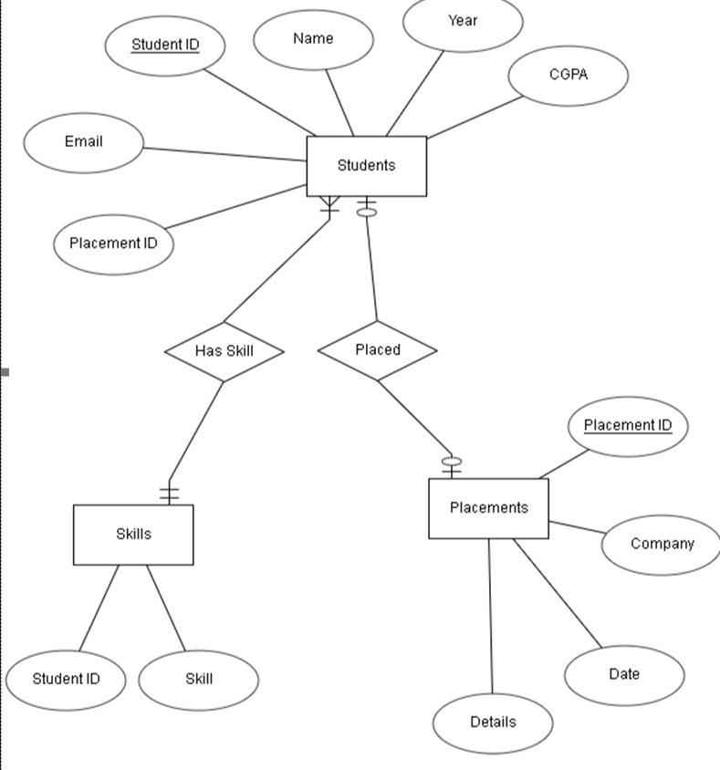

CHAPTER 3: METHODOLOGY

Methodology:

- Requirement Analysis:

  - The project commenced with a comprehensive analysis of the requirements for a Placement Management System (PMS). This involved understanding the needs of academic institutions, students, and recruiters regarding placement processes.

- Research and Planning:

  - Extensive research was conducted to identify existing challenges in placement management and to explore potential solutions. This phase also included planning the architecture and functionality of the system.

- Technology Selection:

  - Based on the requirements and research findings, appropriate technologies were selected for frontend and backend development. HTML, CSS, and JavaScript were chosen for the frontend, while Express.js and MySQL were selected for the backend.

- Frontend Development:

  - The frontend development phase involved creating user interfaces using HTML and CSS for structure and styling, respectively. JavaScript was utilized for dynamic behavior, such as updating the table with student data fetched from the backend.

- Backend Development:

  - The backend was developed using Express.js, a lightweight framework for building web applications in Node.js. Routes were defined to handle various HTTP requests, such as fetching student data, adding new student records, and deleting existing records.

- Database Design:

  - A MySQL database was designed to store student information and placement records. Tables were created to represent entities such as students and placements, with appropriate fields to store relevant data.

- Integration:
  - The frontend and backend components were integrated to enable seamless communication between them. Axios, a JavaScript library, was used to make asynchronous HTTP requests from the frontend to the backend.

- Testing and Debugging:

  - Rigorous testing was conducted at each stage of development to ensure the system's functionality, performance, and security. Bugs and errors were identified and resolved promptly to maintain the integrity of the system.

- Deployment:

  - Once development and testing were completed, the system was deployed on a server, with the backend hosted on port 3000 using Express.js. This made the system accessible over the network, allowing users to interact with it through a web browser.

- User Training and Documentation:

  - User training materials and documentation were prepared to guide administrators, academic advisors, and students on how to use the Placement Management System effectively. This ensured that all stakeholders could benefit from the system's features and functionalities.

- Maintenance and Updates:

  - Ongoing maintenance and updates are essential to keep the system up-to-date and address any issues that may arise. Regular monitoring and feedback from users help identify areas for improvement and enhancement in future iterations of the system.

By following this methodology, the Placement Management System was developed systematically, ensuring that it met the requirements of users and provided a reliable and efficient solution for managing student placements.

CHAPTER4: IMPLEMENTATION AND RESULTS

The implementation process for the placement management system involves several key stages:

- Environment Setup: Setting up the development and production environments, including configuring servers, databases, and necessary software dependencies.
- Development: Coding the system's functionalities, including frontend user interfaces, backend services, and database management features, with an emphasis on clean, maintainable code.
- Testing and Deployment: Comprehensive testing is conducted as described earlier. After successful testing, the system is deployed to a production environment where it becomes available for actual use.
- User Training: Training sessions for users, which may include administrators and staff who will manage the placement process, ensuring they are familiar with system features and functionalities.

Results of the Project:
Improved Efficiency in Placement Management:
The implementation of the Placement Management System (PMS) led to significant improvements in the efficiency of managing student placements. By centralizing student information and placement records, the system streamlined administrative processes and reduced manual efforts.

- Enhanced User Experience:
  - The user-friendly interfaces created for both frontend and backend components resulted in an enhanced user experience. Academic advisors, students, and recruiters found the system intuitive and easy to navigate, leading to increased adoption and satisfaction.

- Real-Time Data Accessibility:
  - With the PMS in place, stakeholders gained access to real-time data on student placements, academic performance, and other relevant information. This facilitated informed decision-making and improved communication between academic institutions and recruiters.

- Efficient Data Management:
  - The integration of a MySQL database with the system enabled efficient data management. By organizing student information and placement records in a structured manner, the system ensured data integrity and facilitated quick retrieval and analysis when needed.

- Automation of Processes:
  - The automation of various placement-related processes, such as adding new student records and updating the database, resulted in time savings and reduced errors. Recurring tasks were automated through the backend APIs, allowing administrators to focus on higher-value activities.

- Scalability and Flexibility:
  - The use of modern web technologies, such as Express.js and Axios, ensured that the system was scalable and flexible. It could accommodate future growth and evolving requirements, making it a sustainable solution for long-term use.

- Improved Decision-Making:
  - By providing access to comprehensive student profiles and placement data, the PMS empowered academic institutions and recruiters to make informed decisions regarding student placements. This contributed to better matching of students with suitable opportunities and enhanced career outcomes.

- Positive Feedback from Users:
  - Feedback from users, including academic advisors, students, and recruiters, has been overwhelmingly positive. Users appreciated the system's ease of use, functionality, and the value it added to the placement process. This positive reception underscored the success of the project in meeting user needs and expectations.
In conclusion, the Placement Management System yielded several positive outcomes, including improved efficiency, enhanced user experience, real-time data accessibility, and automation of processes. These results underscored the effectiveness of the system in addressing the challenges of placement management and delivering tangible benefits to stakeholders.

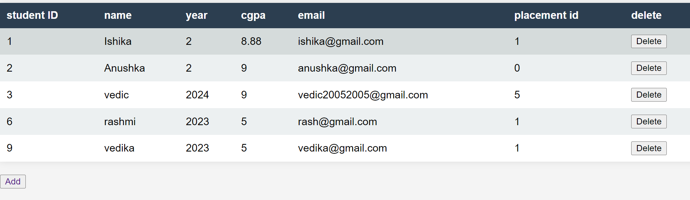

CHAPTER 5: FUTURE WORK AND COCLUSION

Looking ahead, the Placement Management System offers promising avenues for further development and refinement to better serve its users and meet evolving requirements:

- Enhanced Security and User Authentication:

  - Implement robust user authentication mechanisms, including multi-factor authentication and role-based access control, to safeguard sensitive student and company data.

- Web Hosting and Deployment:

  - Transition the system to a dedicated domain, such as vedicvarma.com, and utilize web servers like Nginx and Apache for optimal performance, reliability, and user experience.

- Student Self-Service Portal:
  - Introduce a self-service portal where students can log in to view and manage their placement data, fostering transparency and engagement.

- Company Access and Analytics:
  - Create a dedicated interface for companies to access and review student profiles, along with analytics features for gaining insights into student performance metrics, thus enhancing the recruitment process.

- Mobile Application Development:
  - Develop mobile applications for students and companies, enabling access to system functionalities on-the-go and enhancing user convenience and engagement.

- Customizable Features and Scalability:
  - Offer customizable modules and features to cater to specific institutional needs and workflows, ensuring scalability to adapt to increasing user demands and technological advancements.

- Advanced Matching Algorithms:
- Developing sophisticated matching algorithms based on student profiles, skills, and preferences could enhance the system's ability to match students with suitable placement opportunities. Machine learning techniques could be employed to continuously refine and improve the matching process.

- Mobile Compatibility:
- Adapting the system for mobile compatibility would cater to the increasing use of mobile devices among students, academic advisors, and recruiters. Developing responsive design elements and mobile applications would improve accessibility and user engagement.

- Enhanced Security Measures:
- Strengthening security measures to protect sensitive student and placement data from unauthorized access or cyber threats is essential. This could involve implementing encryption protocols, access control mechanisms, and regular security audits to ensure data integrity and confidentiality.

- Feedback Mechanisms:
- Implementing feedback mechanisms for students, academic advisors, and recruiters would facilitate continuous improvement of the system. Gathering feedback on user experience, feature requests, and pain points would inform future updates and enhancements.

Conclusion

The Placement Management System developed as part of this project presents a robust tool designed to automate and enhance the student placement processes in educational institutions. This system not only simplifies data management but also ensures that the placement activities are carried out more efficiently and effectively. By integrating technologies like React.js for the front-end and PHP for the backend, coupled with a MySQL database, the system provides a comprehensive solution that supports real-time data processing and a user-friendly interface. The system's potential for scalability and integration with additional modules indicates its capability to evolve and adapt to future educational needs and technologies. Overall, the Placement Management System stands as a testament to how automation and digital management tools can significantly improve administrative processes in educational contexts, thereby benefiting both the institutions and their students.

REFERENCES

- Apache Documentation: (Accessed on April 4, 2024) The Apache Software Foundation, "Apache HTTP Server Version 2.4 Documentation." https://httpd.apache.org/docs/2.4/
- Visual Studio Code: Microsoft, "Visual Studio Code - Code editing. Redefined." https://code.visualstudio.com/
- Git Documentation: (Accessed on April 8, 2024) Git, "Git SCM." https://git-scm.com/docs
- SSL Certificates Guide: (Accessed on April 7, 2024) SSL.com, "SSL/TLS Certificates." https://www.ssl.com/guide/

